LED

LED (LIGHT EMITTING DIODE) consists of a chip of semiconducting material impregnated, or doped, with impurities to create a p-n junction. As in other diodes, current flows easily from the p-side, or anode, to the n-side, or cathode, but not in the reverse direction. Charge-carriers—electrons and holes—flow into the junction from electrodes with different voltages. When an electron meets a hole, it falls into a lower energy, and releases energy in the form of a photon.

LED
. 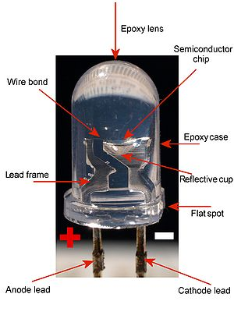
LEDs are usually built on an n-type substrate, with an electrode attached to the p-type layer deposited on its surface. P-type substrates, while less common, occur as well. Many commercial LEDs, especially Gann/InGaN, also use sapphire substrate. Most materials used for LED production have very high refractive indices. This means that much light will be reflected back in to the material at the material/air surface interface. Therefore Light extraction in LEDs is an important aspect of LED production, subject to much research and development.

Efficiency and operational parameters:
Typical indicator LEDs are designed to operate with no more than 30–60 milliwatts [mW] of electrical power. Around 1999, Philips Lumileds introduced power LEDs capable of continuous use at one watt [W]. These LEDs used much larger semiconductor die sizes to handle the large power inputs. Also, the semiconductor dies were mounted onto metal slugs to allow for heat removal from the LED die.
One of the key advantages of LED-based lighting is its high efficiency, as measured by its light output per unit power input. White LEDs quickly matched and overtook the efficiency of standard incandescent lighting systems. In 2002, Lumileds made five-watt LEDs available with a luminous efficiency of 18–22 lumens per watt [lm/W]. For comparison, a conventional 60–100 W incandescent light bulb produces around 15 lm/W, and standard fluorescent lights produce up to 100 lm/W. (The luminous efficiency article discusses these comparisons in more detail.)

Parts of an LED

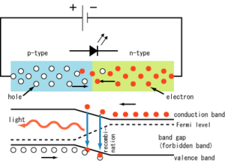

In September 2003, a new type of blue LED was demonstrated by the company Cree, Inc. to provide 24 mW at 20 milliamperes [mA]. This produced a commercially packaged white light giving 65 lm/W at 20 mA, becoming the brightest white LED commercially available at the time, and more than four times as efficient as standard incandescent. In 2006 they demonstrated a prototype with a record white LED luminous efficiency of 131 lm/W at 20 mA. Also, Seoul Semiconductor has plans for 135 lm/W by 2007 and 145 lm/W by 2008, which would be approaching an order of magnitude improvement over standard incandescent and better even than standard fluorescents.^{[14]} Nichia Corporation has developed a white light LED with luminous efficiency of 150 lm/W at a forward current of 20 mA.^{[15]}
It should be noted that high-power (≥ 1 W) LEDs are necessary for practical general lighting applications. Typical operating currents for these devices begin at 350 mA. The highest efficiency high-power white LED is claimed ^{[16]} by Philips Lumileds Lighting Co. with a luminous efficiency of 115 lm/W (350 mA).
Cree issued a press release on November 19, 2008 about a laboratory prototype LED achieving 161 lumens/watt at room temperature. The total output was 173 lumens, and the correlated color temperature was reported to be 4689 K.^{[17]}

The inner workings of an LED

I-V diagram for a diode an LED will begin to emit light when the on-voltage is exceeded. Typical on voltages are 2-3 Volt

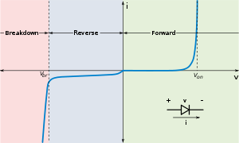

V-I CHARACTERSTICS

